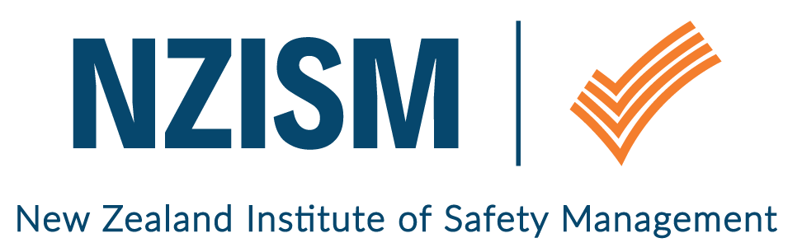
Wellington Branch

May 2019 Newsletter
Monthly update | Kim Payton, the new Wellington Branch Manager, attended one of the regional Connect with Purpose sessions run by the Business Leaders’ Health and Safety on May 7. WorkSafe’s Chief Advisor of Innovation, Daniel Hummerdal, led the session which focussed on using a methodology to work out issues and identifying the problem BEFORE shifting to solution mode. While it was only 90 minutes long, Kim reports that Daniel deliberately kept the group focussed on the problem (not the solution) and it was great to see Daniel showing how innovative thinking can help break down complex issues into achievable steps. All attendees at the workshop were challenged to try the methodology back in the workplace and report back on outcomes.
Review of last event | Tuesday 7 May – 12.30 – 1.30pm  Wellington Branch AGM  24 members attended this year’s AGM. Greg Dearsly, NZISM President, was our guest speaker and he gave an overview of the organisational restructure and draft rules. We have added the presentation to the Wellington Branch page on the NZISM website so as many members as possible are aware of what’s planned.  The centralisation of a lot of the administration functions of branches will help your Committee focus on the CPD and networking activities that you’ve asked for. But a Committee can only be successful if there is a group of people to share the load.  At the AGM, we farewelled James Pinchin (has moved to Tauranga), Josh Dorman (now leading the NZISM Emerging Leaders Group), Denise Steele (has moved to Auckland) and Mike Sarten (busy studying). Thanks to each of you for your time, effort and enthusiasm over the past year. It’s been great working with you.  Kim Payton was elected unopposed as Branch Manager. Jan Houston and Greg Tetzlaff stayed on the Committee as general members, and Steve Logan was elected as a new member.  So, as you can see, we’re a small, but enthusiastic bunch. However, we need at least 4 more people to help keep things ticking along by volunteering about 2 hours of their time each month. The main ‘jobs’ are writing the monthly newsletter, monitoring the NZISM emails, making sure invoices are paid, meet and greet at the monthly seminars, and being responsible for one or two events over 12 months. The committee meets via Zoom every third Wednesday of the month and the intent is to spread the load so everyone does a little each month. If you have some time you could offer to NZISM, please email well.nzism@gmail.com.
June event  Tuesday 4 June  12.00 (for a 12.15pm start) – 1.30pm  National Library  Molesworth Street | Bullying in the Workplace – Pat Copp  Pat will share her tough story of how she was bullied in her workplace, the impact it had on her and those around her, and how she has come out the other side to a point where she can share her success story and why she succeeded. She strongly believes management, and management only, have the power to stop bullying.
Local H&S scene / What’s going on | NZISM Roadshow – Dr Todd Conklin – Wellington, 19 July 2019  The Norwood Room, Basin Reserve, Sussex Street, Wellington  This is a must see event. Todd is an engaging, fun speaker who tackles the mysteries of why people behave the way they do. He is passionate about helping others figure out why systems that allow people to fail safely is good for business. A brochure is attached which includes a link to a short video clip of Todd speaking. This is to provide some information about the types of things Todd will be speaking about for those who are unfamiliar with his work.  Speakers of this quality are rare in NZ. We strongly encourage you to attend.  NZISM Networking Event – Safeguard, Tuesday 28 May 2019  If you’re attending this year’s Safeguard conference, don’t forget to attend the networking event hosted by Greg Dearsley (President) and Selena Armstrong (CEO) are hosting, and the guest speaker is David Clarke, CEO of Safety Institute of Australia.  Check out Greg’s latest newsletter for information on other events coming up.  NZISM Webinars  You can access NZISM webinars you may have missed by logging on to the Members only page on the NZISM website.  If you’d like to promote an event or share information that would be of interest to NZISM members, please email well.nzism@gmail.com.
Other Information | Vacancy – Health and Safety Advisor, Wellington Free Ambulance  Shane Bidois of Wellington Free Ambulance is on the hunt for that perfect person to fill a part time position (24 hours) at their organisation. The Job Description has been attached with the newsletter if you’re interested or know of someone who may be. Please refer all queries to Shane at Shane.Bidois@wfa.org.nz.  Contact information  A reminder to ensure your profile on the NZISM website – https://www.nzism.org is up to date with a current email address. The success of the Wellington branch relies on the input of its members and our ability to send communications to you.
Important stuff | Wellington monthly events are scheduled for the first Tuesday of every month at The National Library, Thorndon. Keep an eye on the NZISM calendar on the website for more information.  A reminder also to check out our neighbouring regions’ events on the NZISM Calendar. There may be something on in another Branch that is relevant to you.

